Company Name : Representative :
Attention : Tel :
Tel : E-mail :
E-mail : Date :
Country : Offer Ref. No :
Project ID (end user) :

Quotation for Cryogenic storage tank

You may find our proposal along with technical specification as below for Cryogenic Storage tank.

We hope you will find everything satisfactory and please do not hesitate to contact us should you or any of your team members have any questions and/or comments regarding our proposal.

Sincerely yours,

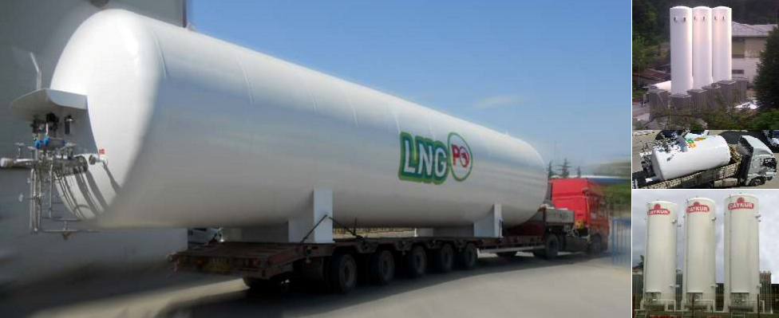

Vessel Technical Specification

- General

  - Type : Vacuum Insulated Storage Tank
  - Design Code : EN 13458
  - Approval : 2014/68/EU CE Marked
  - Fluid : LIN LOX LAR
  - Inner Vessel : Stainless Steel (Acc. To EN 10028-7)
  - Outer Vessel : Carbon Steel (Acc. To EN 10025/10028)
  - Earthquake : Seismic Zone 1 in accordance with UBC1997
  - Wind Load : 45 m/s Acc. To EN 1991-2-4

- Inner vessel
  - Gross Capacity : 20.810 Liters
  - Net Capacity(95% ratio): 19.770 Liters
  - MAWP : 17 Bar
  - Design Code : EN 13458 ANNEX C
  - Design Temperature : -196 °C / +50 °C
  - Material : SS 1,4306 & 1,4307 or equivalent (Acc. To EN 10028-7)
  - Radiographic Control : %100
  - Cleaning : will be cleaned suitable to oxygen use.

- Outer vessel

  - Design Pressure : 1 barg
  - Design Code : EN 13458 / EN 13445
  - Design Temperature : -20 °C / +50 °C
  - Material : Carbon Steel S355 or equivalent (Acc. To EN 10025/10028)

- Insulation
  - Type : Perlite + Vacuum Insulation
  - Perlite Density : 90-100 kg/m³
  - Vacuum Value : 5 x 10⁻²

- Pipework and Accessories

  - Pipe Material : Seamless pipe AISI 304/304L min. sch10
  - Pipework testing : Welds and pressure test
  - Valves : See Accessories List below
  - Safety Valves : See Accessories List below
  - Level Gauges : See Accessories List below
  - Pressure Gauges : See Accessories List below
  - PBUC : Aluminum finned type
(Acc. to Max. 300 Nm3/h LIN discharge capacity with standard pressure building coil at 0,7 x MAWP and 8 hours operating time)
  - Flow schematic : See P&ID below

- Surface Application

  - Sandblasting : Outer tank will be shot blasted with sa 2,5 screen quality
  - Painting : Primer epoxy grey (120 µ)
Topcoat polyurethane white (80 µ)
  - Logo : Logo application price will be given optionally.

- Vessel documentation

  - Inspection Test Plan (ITP)
  - Hydrostatic test certificate
  - Final inspection report
  - Manufacturer’s name plate
  - Tank approval certificate
  - Third party inspection reports
  - Welding procedures and applications
  - Radiographic reports
  - Dye-penetrant reports
  - Material certification

- Inspection

  - Inspection and certification to be carried out by BV or TUV etc.

Commercial Terms and Conditions

Price
- Our prices are net in EURO (€), for delivery Exw. GEBZE/KOCAELİ/TURKEY.
- Standard packing for open transport and export customs clearance are included.
- Seaworthy packing, transport, customs duties and any other charges are excluded.

No | Product | Unit Price | Qty | Total Price
1 | 20 m³ LLL Storage Tank | € | 1 | €
Notes:
- Local certificates are not included in our offer.
- Template, anchor and bolts are not included in our offer.
- All connection (FC,C etc.) will be PN40 DN40 standard flange according to EN.

Payment Terms
- %50 Advance payment
- %50 Before shipment
Delivery Time
- 14-16 weeks after receiving down payment
- Exact delivery date to be agreed at time of order

Warranty
- 12 months after final inspection report prepared by Quality Department
- All resale products and components only carry the warranty offered by their original manufacturer.

Storage Cost
- Cryocan provide 2 weeks free storage after completion excluding handling cost if any
storage fee will be 150$/day after.

Validity
- Our quotation is valid for 30 days
- This quotation letter is valid with Cryocan General Terms & Conditions of Sales

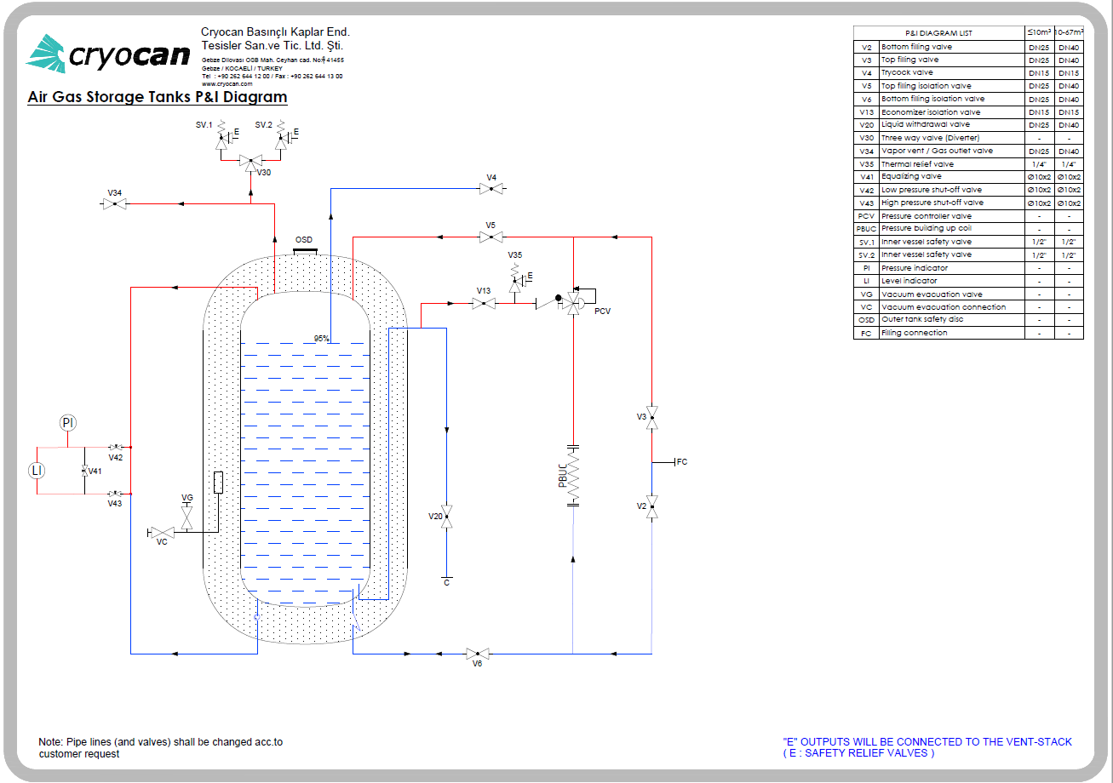

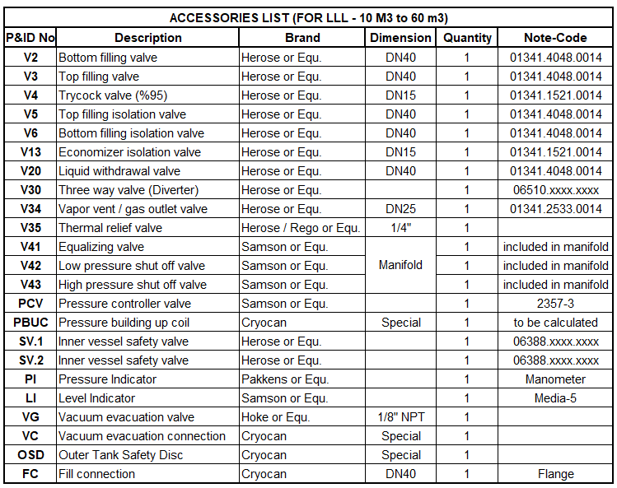

SV : Inner vessel safety valves set pressure will be 17 bar.
PCV : Pressure regulator set point range will be 8-25 bar.

